**Session report 28/03/2023:**

*LABAUVIE – RAFFAELLI EVA*

*ROB3*

I started by cropping the piece I need to 3D print again and then I went back to yolo.

I followed the séance 15 where I left it.



So I installed Torch

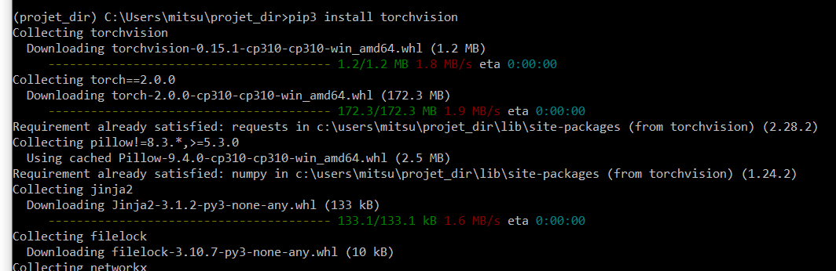

Another error :



So I downloaded the missing package

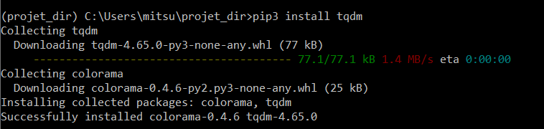

So I mostly uploaded all the missing package and downloaded them with pip3



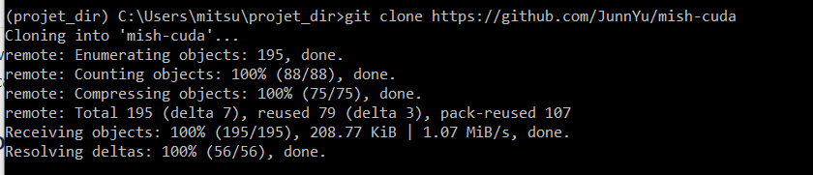

I had to follow : <https://medium.com/analytics-vidhya/cuda-toolkit-on-windows-10-20244437e036>

Because “mish-cuda” wasn’t installed and caused issues, so I first tried to get Conda.